RESOLUTION NO.__________

RE: CERTIFICATE OF APPROPRIATENESS UNDER THE
PROVISIONS OF THE ACT OF THE PENNSYLVANIA
LEGISLATURE 1961, JUNE 13, P.L. 282 (53
SECTION 8004) AND BETHLEHEM ORDINANCE NO.
3952 AS AMENDED.

WHEREAS, it is proposed to add storm windows and shutters, new trim, rebuild entry porch, install metal stair and replace existing walkways at
2 W. Market Street.

NOW, THEREFORE, BE IT RESOLVED by the Council of the City of Bethlehem that a Certificate of Appropriateness is hereby granted for the proposal.

Sponsored by: (s)

(s)

ADOPTED BY COUNCIL THIS DAY OF 2016.

(s)
President of Council

ATTEST:

(s)
City Clerk

HISTORICAL & ARCHITECTURAL REVIEW BOARD
The applicant is proposing to add storm windows and shutters, new trim, rebuild entry porch, install metal stair and replace existing walkways at 2 W. Market Street.
APPLICATION #2:

Herm Rij
2705 Bridle Path Place
Bethlehem, PA 18017

OWNER:

__________________________________________________________________________

The Board upon motion by Marsha Fritz and seconded by Phil Roeder adopted the proposal that City Council issue a Certificate of Appropriateness for the following:

- Install new exit stair to meet current code on side of the building.

- Stair color to match trim color.

- Replacement windows, storm windows and the meeting rail to align with existing.

- Arch top to match existing.

- New shutters to be wood material and functional.

- Existing boards on front porch to be repaired and replaced of like kind material.

- Metal railing on porch to be Muddled Basil color.

8. The motion was unanimously approved.
__________________________________________________________________________

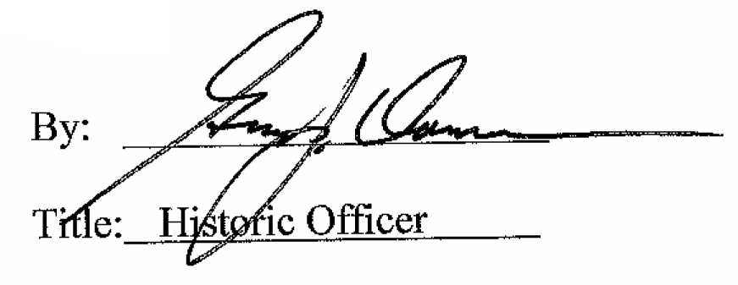

Date of Meeting: October 5, 2016

